

**Vehicle number plate text Extraction using**

**Image Processing**

**MAJOR PROJECT REPORT**

**SUBMITTED BY**

Name of Student(s) University Roll No. SAP ID

Aman Pathak R790313074 500031127

Apoorv Rakshit R790213017 500030646

SUBMITTED IN PARTIAL FULFILLMENT OF THE REQUIREMENTS FOR THE AWARD OF

THE DEGREE OF

**BACHELOR OF TECHNOLOGY**

**In**

(Electronics Engineering)

Under the guidance of

**Dr. Paawan Sharma** **Dr. Adesh Kumar**

Assistant Professor Assistant Professor

( ) ( )



DEPARTMENT OF ELECTRONICS AND INSTURMENTATION & CONTROL ENGINEERING

COLLEGE OF ENGINEERING STUDIES

UNIVERSITY OF PETROLEUM & ENERGY STUDIES

Bidholi Campus, Energy Acres,

Dehradun-248007. April-2017

**DECLARATION BY THE SCHOLAR**

I hereby declare that this submission is my own and that, to the best of my knowledge and beliefs, that the work which is being presented in the B.Tech. Major Project Report entitled **“Vehicle number plate text Extraction using Image Processing”,** in partial fulfillment of the requirements for the award of the **Bachelor of Technology in Electronics Engineering** and submitted to the Department of Electronics Engineering UNIVERSITY OF PETROLEUM & ENERGY STUDIES, Dehradun, India, is an authentic record of my own work carried out during a period from **August 2016 to April 2017** (**8th semester**) under the supervision of **Dr. Paawan Sharma,** **Electronics Department**.

Signature of students:

Aman Pathak (R790213074) Apoorv Rakshit (R790213017)

(ii)

# CERTIFICATE

I hereby Certify that this submission which is being presented in the B.Tech. Major Project Report entitled **“Vehicle number plate text Extraction using Image Processing”,** in partial fulfillment of the requirements for the award of the **Bachelor of Technology in Electronics Engineering** and submitted to the Department of Electronics Engineering UNIVERSITY OF PETROLEUM & ENERGY STUDIES, Dehradun, India, is an authentic record of work carried out during a period from **August 2016 to April 2017** under our supervision. This Project Report has not been submitted by me for the degree elsewhere.

**Signature of Supervisor(s)**

Dr. Paawan Sharma Dr. Adesh Kumar

Assistant Professor Assistant Professor

**(iii)**

**ACKNOWLEDGEMENT**

I would like to express my sincere gratitude to, DR. SUSHABHAN CHOWDURY

HOD-Dept. of Electronics, UNIVERSITY OF PETROLEUM & ENERGY STUDIES, Dehradun, India for his generous guidance, help and useful suggestions.

I express my sincere gratitude to Dr. Paawan Sharma, & Dr. Adesh Kumar, Dept. of Electronics, UNIVERSITY OF PETROLEUM & ENERGY STUDIES, Dehradun, India, for their guidance, and continuous encouragement and supervision throughout the course of present work.

I also wish to extend my thanks to other colleagues for their insightful comments and constructive suggestions to improve the quality of this project work.

**Signature(s) of Students**

Name of Student(s) University Roll No SAP ID Signature

Aman Pathak R790313074 500031127

Apoorv Rakshit R790213017 500030646

(iv)

**ABSTRACT**

The field of AI is not new to us, it has been around since the 1950’s, the term machine Learning is introduced first by Arthur Samuel in 1959 “as the field of study in which computer gains the ability to learn without being explicitly programmed”. It gives the machine the ability to perform on its own and improve itself further by gaining experience.

This Report contains the description of a system designed to make an ANPR (Automatic Number Plate Recognition). It can be used for Mass- surveillance or surveillance of the person of interest, tracking of stolen cars, or vehicles under false registration. This system make use of an onboard computer “raspberry pi”, which is the heart of system.

Whenever a vehicle approaches the system, the image of licence plate is captured by the camera installed on raspberry pi, and then the processor, process the captured image using the K-NN/SVM algorithm(s) to detect the text and numbers on the licence plate of the vehicle and the result is displayed on the LCD connected to the output port of the raspberry pi.

(v)

**TABLE OF CONTENTS**.

**Certificate** *iii*

**Acknowledgement** *iv*

**Abstract** *v*

**List of figures** *vi*

1. **Introduction …………………………………………………………….1**

1.1) Application……….……………………………………………….1

1.2) Industrial Application……………………………………………..2

1.3) Objective of the Project…………………………………………...2

1.4) Types of license plate Recognition system………………………..4

1.5) Challenges in ANPR………………………………………………4

1. **Literature Review……………………………………………………………7**

2.1) Problem Statement…………………………………………………..7

2.2) system Design……………………………………………………….7

2.3) Previous works done in this field (Selected Papers)………………...9

2.4) an overview of the System………………………………………….12

Preprocessing Technique…………………………………….12

2.4.1) Conversion to Grayscale………………………………12

2.4.2) Gaussian Filtering……………………………………..12

2.4.3) Enhancing the Contrast………………………………..12

**2.5) Localization of Plates………………………………………………….14**

2.5.1) Detection of Edges……………………………………………14

2.5.1) Gradient method…………………………………………..14

2.5.1.2) Laplacian Method………………………………………14

2.5.1.2a) Sobel Filter…………………………………14

2.5.1.2b) Laplacian Derivative……………………….15

2.5.1.2c) Canny Edge Detection………………………..15

2.5.1.3) Otsu’s Binarization………………………………………….16

**2.6) Contour……………………………………………………………………….17**

2.6.1) contour Selection…………………………………………18

* Contrast Present in Contour……………….18
* Aspect Ratio……………………………….18
* License Plate Width………………………..18
* Total number of Pixels……………………..19

**2.7) Character Segmentation…………………………………………………..19**

**2.8) OCR using K-NN (Machine Learning algorithm)………………………..20**

2.5.1 Brief Introduction of K-NN…………………………………20

**3.) Materials and Methodology…………………………………………………….21**

3.1) Material Used………………………………………………………….21

3.2) Methodology…………………………………………………………..23

3.2.1 Training the System using k-NN……………………..23

3.2.2 Program to train the system…………………………..23

3.2.3 Program to test the system……………………………27

3.3) License plate detection using K-NN …………………………………..34

1. Original image……………………………………34
2. Grayscale image………………………………….34
3. Threshold of the image…………………………..34
4. Drawing Contours………………………………..34
5. Smoothening of image(noise Reduction)………....35
6. Character detection in contours…………………..36
7. Drawing Contours over the possible plates………36
8. Extracting the plates……………………………...36
9. Conversion of extracted plates to grayscale……...36
10. Threshold of the extracted plates………………....36
11. Smoothening and resizing of the plate image……37
12. Segmentation……………………………………..37
13. Output…………………………………………….37
14. Output in Python shell……………………………38

**4.) Result and Discussion………………………………………………………39-43**

1. **Conclusion………………………………………………………………………44**

**REFRENCES ……………………………………………………………………....45**

|  |  |  |
| --- | --- | --- |
| **Page no.** | **Figure** | **Title** |
| 3 | Fig. 1 | Types of number plates |
| 5 | Fig. 2a | Blurred and Low resolution image |
| 5 | Fig .2b | Low level of Sharpness. |
| 6 | Fig.2c | Highly distorted image |
| 6 | Fig.2d | Bad lightning condition |
| 6 | Fig.2e | Low contrast |
| 7 | Fig. 2 | ANPR process |
| 13 | Fig. 3a | Original image |
| 13 | Fig.3 b | Grayscale image |
| 13 | Fig.3 c | Gaussian filtered image |
| 13 | Fig.3 d | Histogram equalized image |
| 15 | Fig.4a | Sobel x order |
| 15 | Fig.4b | Laplacian |
| 16 | Fig.5 | Canny edges |
| 16 | Fig.6 | Otsu’s binarization |
| 21 | Fig.7 | Raspberry pi model B |
| 22 | Fig.8 | System Setup |
| 22 | Fig.9 | GUI |

|  |  |  |
| --- | --- | --- |
| 23 | Fig. 10 | Training Character images |
| 33 | Fig. 11 | Output of the Test data |
| 33 | Fig .12 | Python Shell output |
| 34 | Fig.13 | Original image of licence plate |
| 34 | Fig.14 | Grayscale image |
| 34 | Fig.15 | Threshold of the image |
| 35 | Fig.16 | Drawing contours over the threshold image |
| 35 | Fig.17 | Smoothening of the image |
| 35 | Fig.18 | Character detection |
| 36 | Fig.19 | Drawing contours over the possible plates |
| 36 | Fig.20a | Extracting the plates -1st plate |
| 36 | Fig.20b | Extracting the plates -2nd plate |
| 36 | Fig.21 | Converting the extracted possible plate into grayscale |
| 36 | Fig.22 | Threshold image of the extracted grayscale image of the possible plate |
| 37 | Fig.23 | Smoothening of the image (noise reduction) |
| 37 | Fig.24 | Segmentation to find out the characters |
| 37 | Fig.25 | Output on the original image |
| 38,40 | Fig.26,27 | Python shell output |
| 41 | Fig.28 | Chart to show efficiency of localization of plate |
| 42 | Fig.29 | Performance analysis |

(vii)

**Chapter -1**

**INTRODUCTION**

1. **Introduction:**

Vehicle number plate Text extraction system or simply ANPR System is generally used in Intelligent Transportation systems (ITS).The use of vehicles is increasing day by day (Due to high population growth),Now as the number of vehicles are increasing, effective control and keeping a check on the vehicles are getting a little tougher.

Here ANPR system provides a good method to keep an effective control of these vehicles.

**So what is an ANPR?**

It is an Image processing algorithm used for identifying the number from a number plate with minimal or even no intervention from the human side.

Other names for the ANPR

* Vehicle number plate Text extraction.
* License plate Recognition
* Number plate tracking etc.

It can be used in various application, which can help to save huge human efforts and cost. Such as:

* 1. **APPLICATIONS:**
* Traffic monitoring
* At toll Plaza (automatic Ticketing)
* Journey time measurement
* Stolen Car Detection

(1)

* Tracking vehicles during signal violation
* Tracking Person of interest or Getaway Vehicles
* Extracting the number plate and saving into a database.

* 1. **Industrial application:**

Many companies in India are working on the on the intelligent systems to make the transportation intelligence

* Advanced Driver Assistance System (ADAS)
* Forward collision Warning (FCW)
* lane Detection
* ANPR
* Self-Driving Car
  1. **Objective of the Project :**

The objective of the project is to develop a system to extract the Indian number plate.

As the Indian number plate is a little hard to extract as compared to plates of the other countries. As The foreign Countries follow the standard procedure of **Aspect Ratio** to Extract the Plate.

**Aspect Ratio = Width of image / Height of image**

But in India there is no standard is being followed for Aspect ratio. This makes the Segmentation and Character Recognition a little bit difficult procedure to extract the text from image.

(2)

**There are a variety of plates in India:**

1. White background with black numbers.(personal Vehicles)
2. Yellow backgrounds with black numbers. (Cab, Taxi, autos)
3. Blue plates with white numbers. (used by Foreign consulates)
4. Black plates with white numbers. (used by Defense personnel)

Fig.1) Typical Indian Number Plate

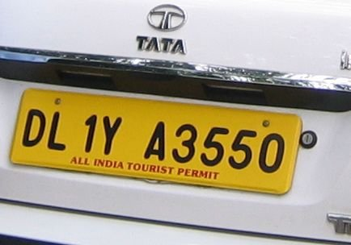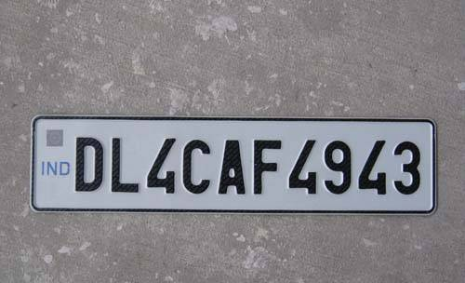

(Personal Vehicle) (Cabs, Autos, Taxis)

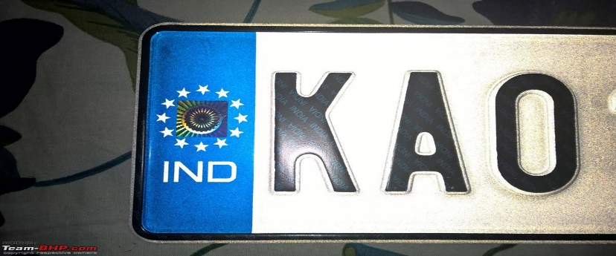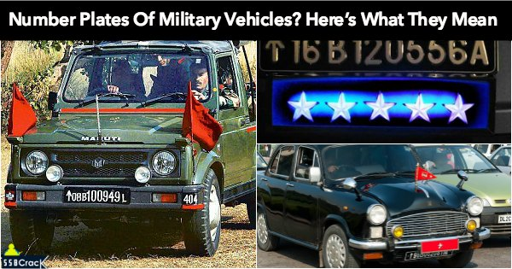

(Defense Personnel) (Foreign Consultant)

(3)

Currently the Indian number plate consist of following registering scheme (Letters and numbers):

* The first two letter code gives the state in which the vehicle is registered002E
* Following is a two digit code specifying the district and series code
* Continued by a series of 4 digit actual registration number of the vehicle.

1.4) **Types of License plate extraction methods.**

1. Online ANPR system: In an online ANPR structure, the impediment and explanation of labels happen expeditiously from the moving toward video plots, empowering Real-time following through the observation camera.

2. ANPR system (offline): A logged off ALPR structure, strikingly, gets the number plate pictures and stores them in a concentrated data server for further processes, i.e. for interpretation of labels.

1.5) **Challenges:**

In the made countries the characteristics of the labels are totally kept up. For example, the measure of the plate, shade of the plate, content style confront/estimate/shade of each character, scattering between resulting characters, a number of lines in the label, script et cetera are kept up especially. A few the photo of the standard labels used as a piece of made nations.

System has two major noteworthy necessities

1. The clarity of the license plate algorithm.

(4)

Image acquisition technique is used to acquire image with good quality to implement the detection algorithm, if the acquired image has a good quality than the accuracy of the detection algorithm will be much more. Better quality of the image implies higher accuracy.

A good quality image is said to be acquired if it has following Properties.

1. Excellent Sharpness and Contrast
2. Good lighting condition
3. Excellent Resolution and Decent angle of View

Example of some of the images which may cause problem (in Fig 2.)

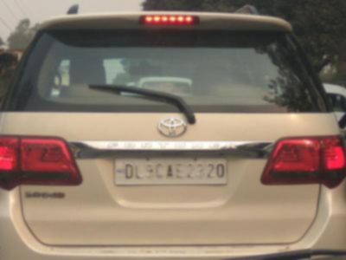

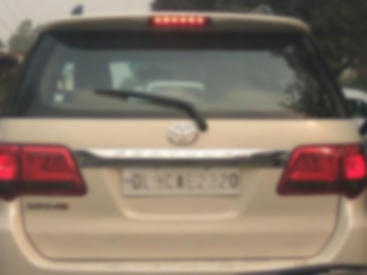 Fig 2.a) Blurred and Low resolution image

Fig 2.b) Low level of Sharpness.

(5)



Fig 2.c) highly distorted image



Fig 2.d) Bad lightning condition



Fig 2.e) low Contrast

Image Courtesy: [www.platerecognition.info](http://www.platerecognition.info)

(6)

**Chapter -2**

**Literature Review**

2.1) **Problem statement**:

The aim of the project is to design a system that captures the picture of the license plate and then processing is done to collect the text & numbers from it using algorithms such as K-NN/SVM.

2.2) **System Design:**

Generally, an ANPR is made up of 5 modules

a.) License number plate detection

b.) Segmentation

c.) Classification

d.) Character segmentation

e.) Optical character recognition (OCR)

Image Preprocessing

Plate Detection

Segmentation

K-NN Training

Optical Character recognitions

Fig.2 ANPR Process

(7)

* Firstly, the image is preprocessed by raspberry pi.
* License plate is localized from the captured image.
* Secondly, the character is segmented from the localized license plate.
* Finally, OCR of the segmented image.

It is surely understood responses for label limitation in electronic pictures are through the execution of edge detection, morphological operation and Sobel operators. An edge methodology is customarily direct and snappy. Sobel director for edge revelation gives helpful results on the photo. The confinements of labels through morphologically based procedures is not helpless to racket yet rather is direct in execution.

After the impediment of the label comes the character division handle. Ordinary character division techniques rely on upon histogram examination and thresholding. Other late proposed methods are the use of neural frameworks.

The last part of an ANPR system is the character recognition process. To oversee different assortments found in characters transversely over different labels will require the divided character to experience some pre-dealing with ventures, for instance, skew revision and standardization. These additional steps wind up being valuable as it essentially reduces the required time of the process.

(8)

2.3) **Previous work done in this Field**:

1. **ALPR using openCV [1]**

**Automatic License Plate Recognition using OpenCV By Pratiksha Jain, Neha Chopra, Vaishali Gupta (Department of CSE, GGSIPU New Delhi, India)**

**Review**: This Paper gave an outside idea of the use of OpenCV over MATLAB, while the MATLAB uses license and OpenCV is free to use. This paper show the use of OpenCV and OCR, dataset was very small (36 images), so efficiency was not good. Due to less Dataset, there is an issue of TIME COMPLEXITY & SPACE COMPLEXITY, as a typical OCR has a 2^16(Unicode) symbols.

1. **Automatic number plate Recognition systems by AmrBadr ,ahmed M. ,Thabet, Abdelsadek**

**Review:** The aim of thepaper is to design a system to detect number plates and extract the number using OCR, and discussion of other method problems such as machine vision, pattern recognition and neural networks. The system algorithm was tested on the snapshots of the vehicles images and divided in to various process such as preprocessing, edge detection etc. The results were not efficient due to smaller dataset. It can be improved using neural networks.

1. **SVM based LPR systems**

**Review:** The main objective of the paper was to use Support Vector machine algorithm to detect the plates and identify the text on the number plate of a poor quality image in real time application. As it can achieve faster recognition in the bad lightning condition as well.

**(9)**

1. **LPR system using Raspberry pi**

**Review:** The aim of the paper was to design a system which utilizes a SOC (system on a Chip) ARM processor to Authenticate a license plate from existing database if the image is in database it will open the gate(barrier), otherwise it will inform the concerned authorities. This paper mainly discuss a vague idea of the use of image processing and use of raspberry pi. No steps of the how to achieve? , were given.

1. **ALPR using python and OpenCV**

**Review:** The aim of paper is to design a system which utilizes OpenCV and   
Python to do the extraction and identification of the text. This paper utilizes a very old technique named OCR tesseract, removal of blobs after segmentation using pixel coordinate method and Aspect Ratio method. The main drawback is that it uses old techniques to identify and extract the text, and fails under bad illumination condition.

1. **LPR System by**

**Review**: The main objective of the paper was to design a system to identify Romanian   
number plates, the stage of Preprocessing used the prewitt edge detector operator, then is further processed to remove any noise. Then localization of the plate takes place further string detection to rule out other non-contributing text in the contour. It was used on a very small dataset so, the system is not completely trustworthy.

(10)

1. **Vision based Text Recognition using Raspberry Pi By Nagaraja L ,Nithin D ,Nagarjun R ,Veena S Murthy,Nishanth M Anand Dept. of ECE, BNMIT 12th Main, 27th Cross, BSK 2nd Stage, Bangalore-70.**

**Review:** The objective of the paper was to use the raspberry pi to build a system which can be useful to blind people, as the image is processed and text is extracted and then is converted to speech (TTS). The idea of the paper is too vague to implement and no methodology was given to implement the system just an overview of the system.

1. **ANPR for vehicle**

**Review:** The proposed system utilizes neural networks to identify the number plate and text is extracted using ANN. This paper suggest a good methods. But there are certain drawbacks of this systems such as Speed of the vehicles, camera angles, captured picture quality, skewness of the picture. This can be further improved by increasing the capability of the algorithm and getting more Datasets and adding features.

(11)

2.4) **An overview of the system**

Preprocessing Technique (utilized for the localization of the plates)

Following techniques are used for the preprocessing of the image.

2.4.1) **Conversion to Grayscale image**:

The RGB components are separated from the 24 bit color value from the pixels value (i,j) to calculate 8 bit Grayscale image using the equation:

$Gray (i,j)= 0.59*R(i,j)+ 0.30*G (I,j)+0.11*B(i,j)$

In python (code) : cv2.cvtColor(I, cv2.COLOR_BGR2GRAY)

2.4.2) **Gaussian Filtering:**

In it Gaussian kernel is used with a specified width and height of the kernel. It is highly effective removing the Gaussian noise.

In python language it is invoked by code:

cv2.GaussianBlur ()

2.4.3) **Enhancing the contrast:**

Using the histogram equalization technique the contrast of the picture can be enhanced. As the grayscale image is an 8 bit image containing 256 levels of gray image ranging from (0 to 255).These 256 levels are modified to enhance the contrast of the image.

In python language, it is invoked by code:

cv2.equalizeHist ()

(12)

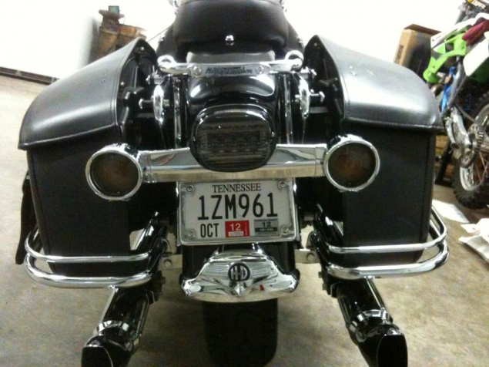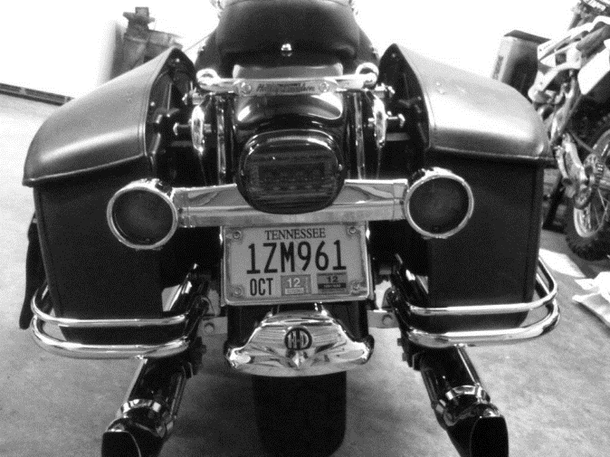

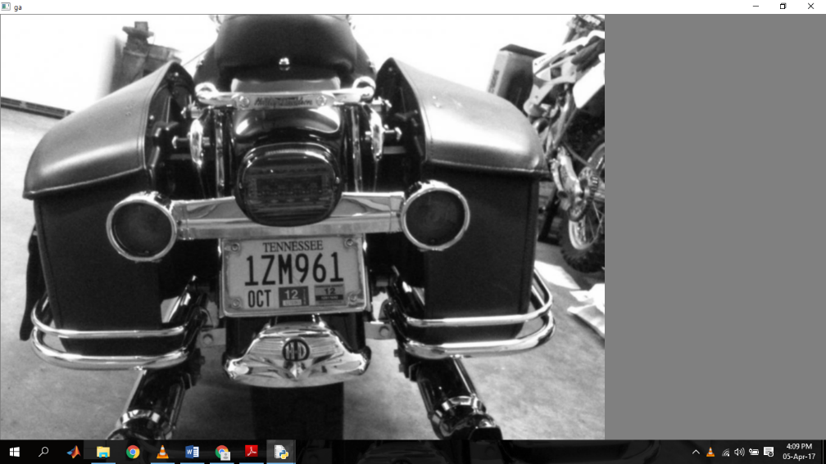Figure .3.a) original img Figure .3 b) Grayscale image

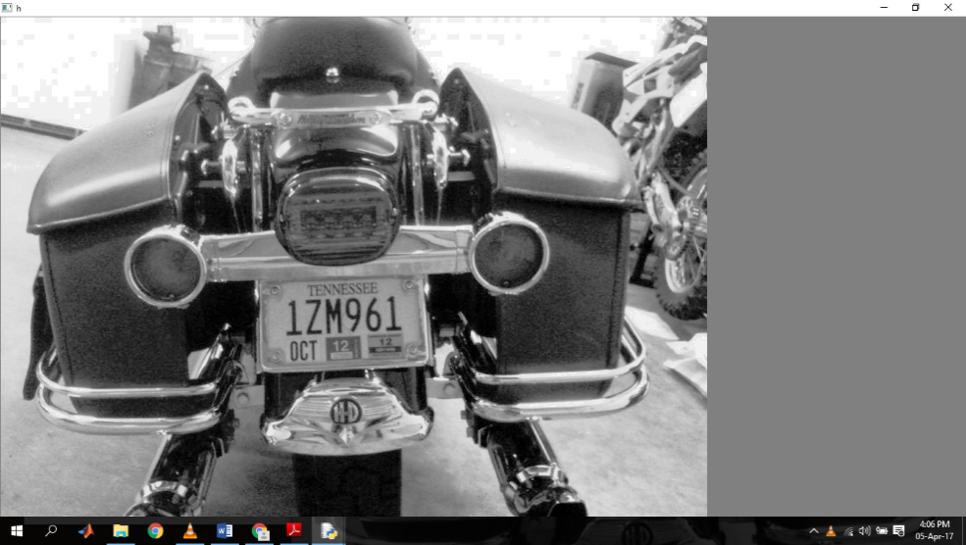

Fiure .3.c) Gaussian Filter Figure 3d) Histogram Equalized

(13)

**2.5) Localization of Plates**:

This very technique is used to find out the region of interest (ROI) or LPR from the given images. Camera captures images. And localization done to find the potential license plate region. Image Preprocessing is done firsthand to improve the quality of the image. Since they are placed in the same row, resulting in the change in the quality of horizontally, as numbers contained in the row will show sharp variation in contrast. This is because of the difference of contrast level between the letters and background (Black and yellow, or Black and White).

2.5.1) **Detection of Edges:**

Edge detection is done to find the boundaries. Edges are the region in the image which has high contrast (a sudden change in the intensity of pixels), it helps in the detection of edges (which reduces the amount of data to be checked, as useless data is not checked and only the potential data is taken.

Edge: It has the 1D shape of the ramp, so by finding the derivative of the same we can tell the location in the image. Edges has higher pixel values than the surrounding pixels.

There are two methods to perform edge detection

2.5.1.1) **Gradient method**: It detects the image by utilizing first derivative in image. It finds the maximum and minimum of the first derivative of the images to find the edges.

2.5.1.2) **Laplacian strategy**: It uses the second subsidiary in the picture. It finds the zero intersection in the second subsidiary of the picture to discover the edges.

• **Sobel Filter**: It uses Gaussian smoothening and in addition separation operation, so clamor impact is a great deal less in it. Uses x request and y request to indicate the bearing of the subordinate to be taken, on a level plane or vertically

* .

(14)

* **Laplacian Derivative:**  Since images are “*2D*”, so it is important to take the derivative in both dimensions. So we utilizes the laplacian derivative.

Code: laplacian = cv2.Laplacian (img, cv2.CV_64F)

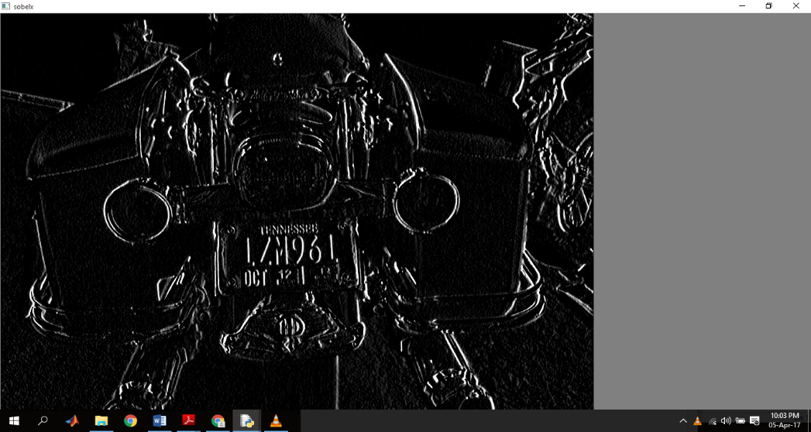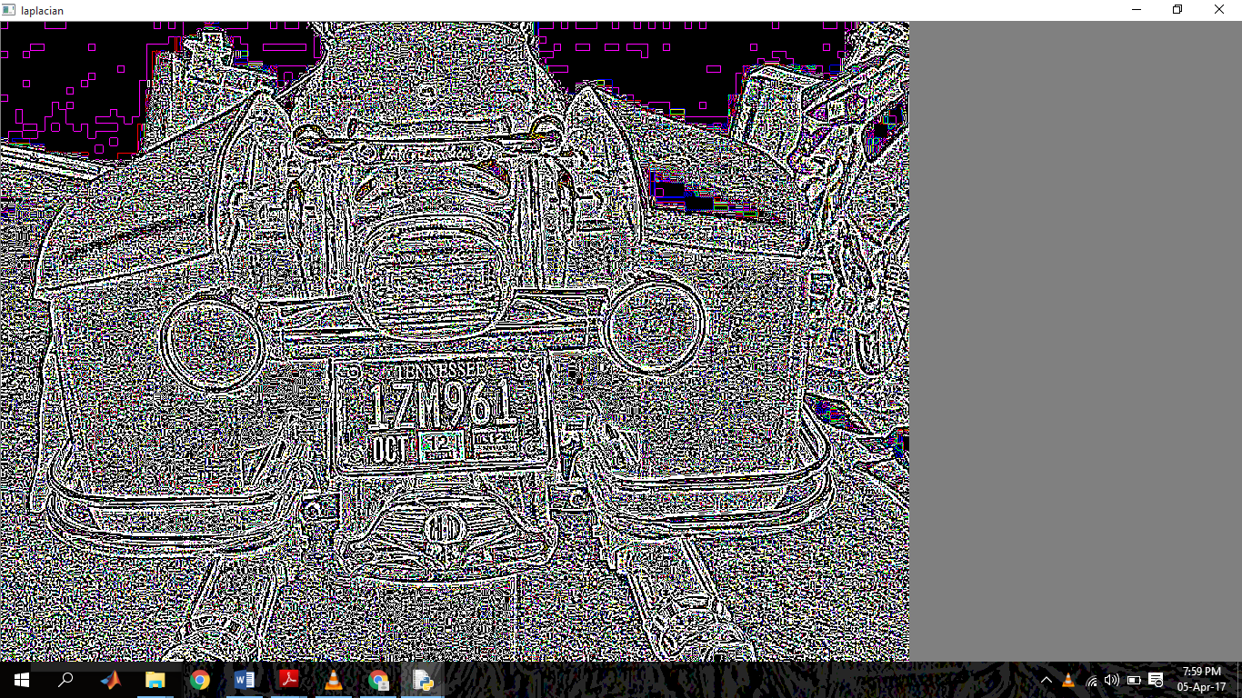

Fig. 4.a) sobel x order fig.4b) Laplacian

* **Canny Edge Detection**: It is the most popular edge detection algorithm.it goes through various stages.

1. Noise Reduction: it is done to remove the noise using Gaussian filtering, to smoothen the image.
2. Finding intensity gradient of the image: using the sobel kernel in both the direction horizontal $(Gx)$ and vertical $(Gy)$. From these two images, we can find edge gradient and direction for each pixel as follows:

Edge gradient $(G) = √(Gx)² +(Gy)²$

$Angle (t) = tan inv(Gx/Gy)$

Slope is opposite to edge so it is adjusted off to one of the 4 points speaking to even, two diagonals and vertical headings.

(15

1. **Non maximum suppression:**

Now a scan of image is done to remove any useless pixel, not constituting the image.

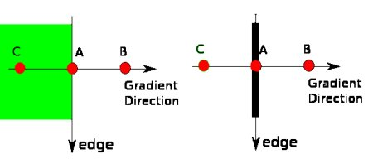

1. **Hysteresis Thresholding:**

Two variables are required maximum value and minimum value to decide which edges are surely and which are not. Edges with intensity gradient more than *maximum value* are sure to be edges and those below *minimum value* are sure to be non-edges, so discarded. Now those which lie in-between are called edges if they are connected with the edges for sure. Else, they are discarded.

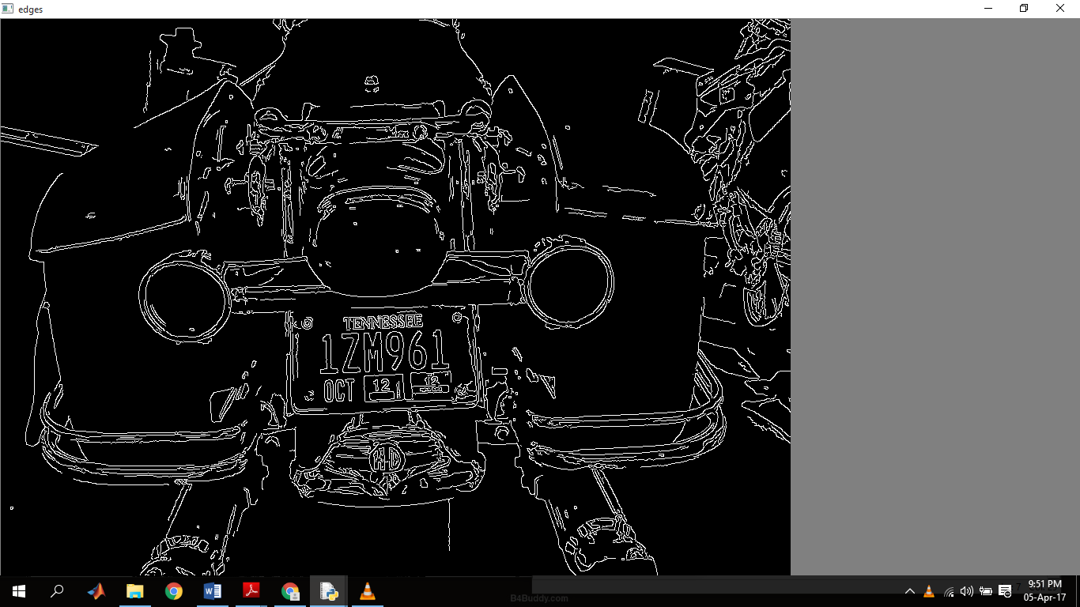

Fig.5) Canny edges

(16)

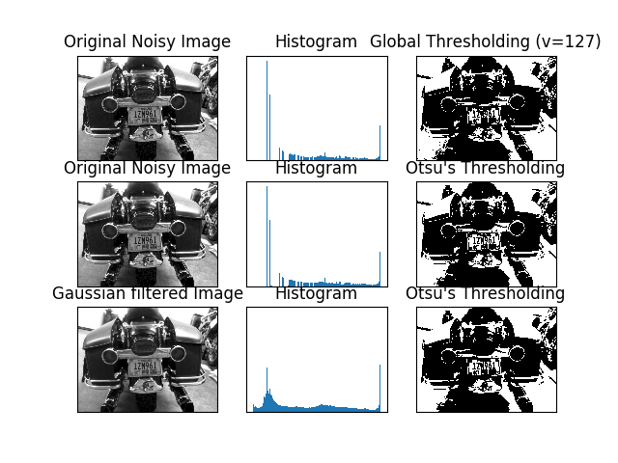 Fig.6) Otsu Binarization model

**2.5.1.3) How Otsu’s Binarization Works?**

Otsu’s algorithm calculates a threshold value (t) which minimizes the **weighted within-class variance** given by the equation:



(17)

**2.6) Contour /Bounding boxes**:   
  
The case with the littlest measure inside which every one of the focuses lie is the base or the littlest jumping or the encasing enclose for any point set N measurements. The base box is normally called as needs be contingent upon the measure utilized, this is especially pertinent when different types of estimation are used.eg. "Least edge jumping box". An intriguing truth that can be utilized to heuristically build the calculation speed is that the base bouncing box of any point set is same as the base jumping box of its raised structure. Because of the utilization of the rectangular Cartesian co-ordinate framework the expression "box"/"hyper rectangle" has come into use, where it can be undoubtedly pictured as a rectangle, rectangular parallelepiped and so forth. On account of 2D it is known as the base jumping rectangle which has the base tallness and which that covers every one of the pixels show in a specific associated segment or district.

**2.6.1) Contour Selections**

For a given image there can be many bounding boxes identified but to select the best possible candidate for license plate region requires to identify few properties of the license plates as discussed below:

1. Contrast present in the Contours: A license plate generally consists of dark colored numbers which are imprinted onto the lighter background. If the image is binarized, the center row of the box can be scanned and total number sudden contrast change can be recorded. The box that have the maximum variation in contrast within the box then it is the possible candidate for the license plate.

2. Aspect Ratio: The aspect ratio of an image is the ratio of the width of the image to its height. Aspect Ratio’s inverse should be less than 1 for any license plate. Hence, the regions doesn’t satisfy this property can be rejected.

3. License plate Width: license plate’s width region also has a threshold limit.it cannot be more than some threshold value. After analyzing various dataset the threshold limit has been chosen to be used.

(18)

4. Total no. of pixels in license plate area: one more factor that separates license plate region from the rest is the amount of pixel that it has in it.

**2.6.2) Contour cropping**

From the best possible Contour of the license plate, the coordinates of the contour are noted and the obtained contour is cropped from the image and sent to character segmentation module for the further processing.

**2.7) Segmentation method**

The character segmentation process is used as a bridge between plate detection and optical character recognition modules. Its main function is to segment the characters in the selected candidate region i.e. extracted license plate such that each character can then be sent individually to the optical character recognition module for recognition.

Normalized or standardized are of a decorated format, the conditions of the license plates, that are an important criteria for efficient segmentation because if the numbers are of a fancy format the conditions of the license plate as described .Once the license plate is localized we can proceed to obtain the individual characters .A license plate as described above is composed of high intensity variation regions. This forms the basis for character segmentation. Sometimes it is observed that along with license numbers, various texts may be present, which have to be removed. Experimentally, we observed that for the license plate areas the amount of white on black is specific for the number regions and falls within a certain range.

Often morphological techniques are used to remove the small white areas which tend to escape range corrections. Then the individual characters are retrieved to pass on through the OCR system. Segmentation is the most important processes in the ANPR, because all further steps rely on it. The 2nd phase of the segmentation is increasing the efficiency of segments.

(19)

**2.8) OCR of license plate using K-NN (Machine Learning algorithm)**

We have utilized K-NN algorithm for the character recognition of license plate.

2.8.1) **Brief Introduction of K-NN:**

It is the simplest classification algorithm available for supervised learning. The objective is to search for the closest match of the testing data in the dataset.

**What is supervised learning**?

In this type of learning, we have a dataset and we already know what our output should look like, we know the relation between the input and output.

**So, what is classification?**

In classification Problems. We are trying to predict output that are discrete. Or in other word, trying to map input variables into discrete categories.

K-NN is a type of non- probabilistic classification. It is a method to check the nearest neighbor

**Why nearest neighbor?**

Because classification depends only on the nearest neighbor.

K should be odd as well to avoid the situation of tie between the classes (feature set)

We have utilized K-NN to train the system to find the numbers and alphabets on license plate by using a training set and testing the data (avoiding over fitting).

(20)

**Chapter -III**

**Materials & Methodology**

**3.1) components**

**3.1.1) Hardware**

1. **Raspberry pi :**

It is a single board computer, commonly termed as Rpi (Raspberry pi).It has its own os (Raspbian).

**Overview of Raspberry pi:**

* It uses BCM2836 system on chip (SoC)
* Quad core Arm cortex A-7 processor
* 256 kB shared L2 cache.
* 1 GB RAM
* Connectivity:10/100MBits/s, wireless (802.11n),Bluetooth 4.1
* 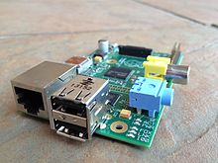

Fig.7 Raspberry pi model B (courtesy Wiki)

3.1.2) Software:

Language: Python software : OpenCV ,Modules : numpy,sklearn,scipy,inbuilt modules

(21)

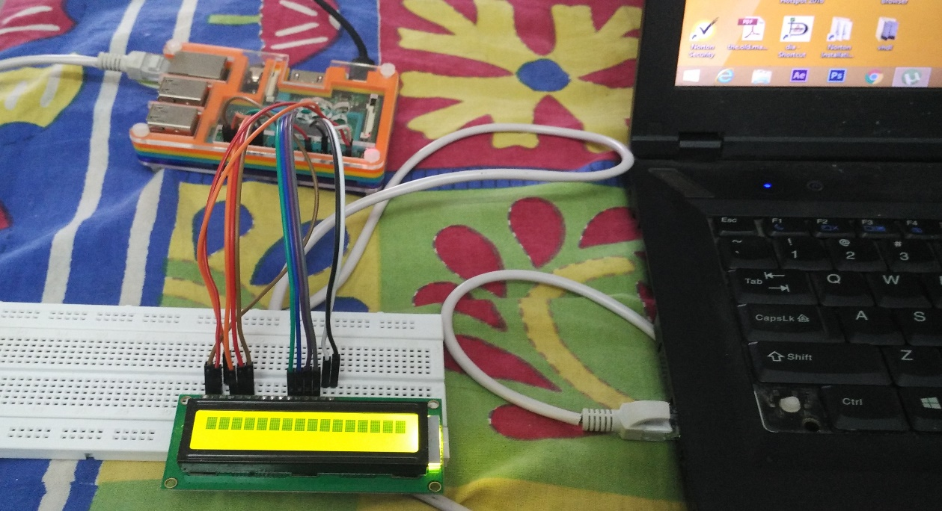**Fig.8) System setup**

**Fig. 9) GUI**

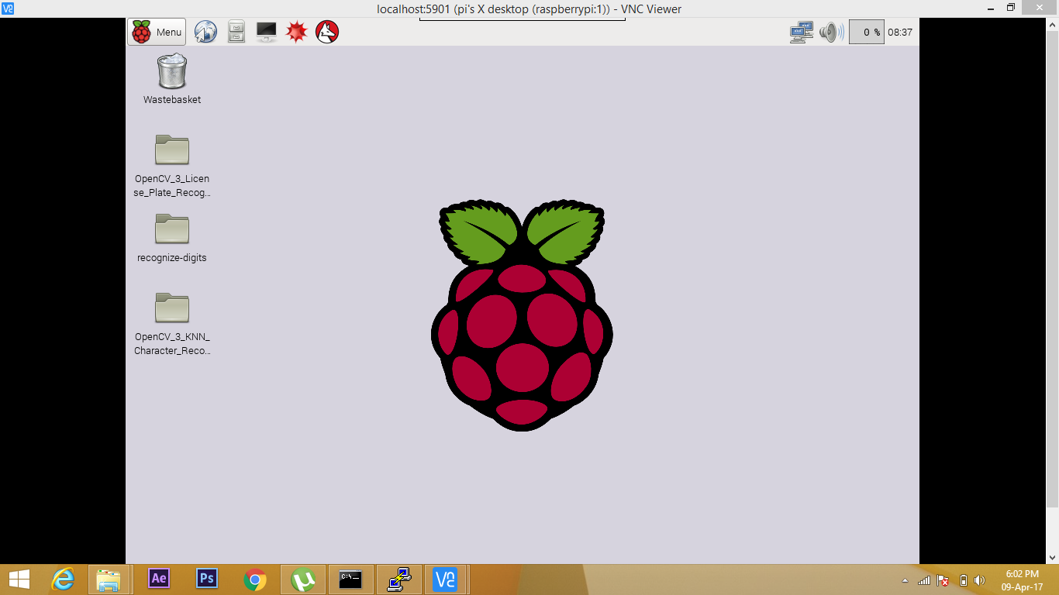

**(22)**

**3.2) Methodology:**

3.2.1) Training the system:

Fig. 10) Training Character image

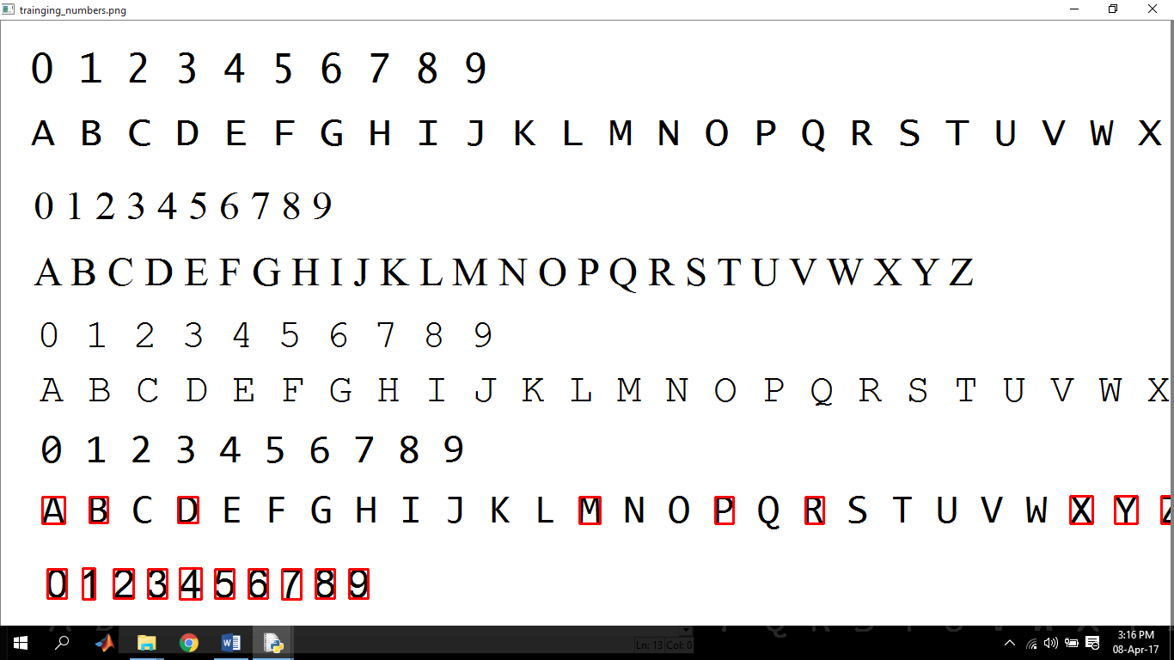

The system is trained to identify the characters as well as the numbers.  
Giving an accuracy of 91.3%

3.2.2) Program to train the system:

##############################################################################

import sys

import cv2

import os

import numpy as np

Contour_Area = 100

image_height = 30

image_width = 30

(23)

def main():

img = cv2.imread("training.png")

if img is None:

print("error:no image\n\n")

os.system("pause")

return

gray = cv2.cvtColor(img,cv2.COLOR_BGR2GRAY)

blur =cv2.GaussianBlur(gray,(5,5),0)

thresh =cv2.adaptiveThreshold(blur,255,cv2.ADAPTIVE_THRESH_GAUSSIAN_C,

cv2.THRESH_BINARY_INV,11,2)

cv2.imshow("thresh",thresh)

threshcopy = thresh.copy()

contours,ncontours,nhierarchy = cv2.findContours(threshcopy,cv2.RETR_EXTERNAL,cv2.CHAIN_APPROX_SIMPLE)

flattenedimages = np.empty((0,image_width*image_height))

intclassifications =[]

(24)

intvalidchar = [ ord('0'), ord('1'), ord('2'), ord('3'), ord('4'), ord('5'), ord('6'), ord('7'), ord('8'),ord('9'),ord('A'), ord('B'), ord('C'), ord('D'), ord('E'), ord('F'), ord('G'), ord('H'), ord('I'), ord('J'), ord('K'), ord('L'), ord('M'), ord('N'), ord('O'), ord('P'), ord('Q'), ord('R'), ord('S'), ord('T') ord('U'), ord('V'), ord('W'), ord('X'), ord('Y'), ord('Z')]

for ncontour in ncontours:

if cv2.contourArea(ncontour) > Contour_Area:

[intX,intY,intW,intH] = cv2.boundRect(ncontour)

cv2.rectangle(img,(intX,intY),(intX+intW,intY+intH),(0,0,255),2)

iROI = thresh [intY:intY+intH, intX:intX+intW]

iROIResized = cv2.resize (iROI, (image_width, image_height))

cv2.imshow("iROI",iROI)

cv2.imshow("iROIResized",iROIResized)

cv2.imshow("trainging_numbers.png",img)

intChar = cv2.waitKey(0)

if intChar == 27:

sys.exit()

elif intChar in intvalidchar:

(25)

intclassifications.append(intChar)

flattenedimage = iROIResized.reshape(1,image_width*image_height)

flattenedimages = np.append(flattenedimages,flattenedimage,0)

fclassification = np.array(intClassifications,np.float32)

nclassification = fclassification.reshape(fclassification.size,1)

print("\n\ntraining done!!\n")

np.savetext ("claasification.txt",fclassification)

np.savetext ("flattened_images.txt",flattenedimages)

cv2.destroyAllWindows()

return

if __name__ == "__main__":

main()

End of Program ##############################################################################

(26)

3.2.3) Program to test the data:

import cv2

import numpy as np

import operator

import os

CONTOUR_AREA = 100

IMAGE_WIDTH = 20

IMAGE_HEIGHT = 30

class ContourData():

nContour = None

boundRect = None

rectX = 0

rectY = 0

rectW = 0

rectH = 0

FloatArea = 0.0

(27)

def calc(self):

[intX, intY, intW, intH] = self.boundRect

self.rectX = intX

self.rectY = intY

self.rectW = intW

self.rectH = intH

def check(self):

if self.FloatArea < CONTOUR_AREA: return False

return True

def main():

contourData1= []

validdata1 = []

try:

nclassifications = np.loadtxt("classifications.txt", np.float32)

except:

print ("error, unable to open classifications.txt, exiting program\n")

os.system("pause")

return

(28)

try:

nflattenedimg = np.loadtxt("flattened_images.txt", np.float32)

except:

print ("error, unable to open flattened_images.txt, exiting program\n")

os.system("pause")

return

nclassifications = nclassifications.reshape((nclassifications.size, 1))

knear = cv2.ml.Knear_create()

kNearest.train(nflattenedimg, cv2.ml.ROW_SAMPLE, nclassifications)

imgtestno = cv2.imread("test1.png")

if imgtestno is None:

print ("error: image not read from file \n\n" )

os.system("pause")

return

imGray = cv2.cvtColor(imgtestno, cv2.COLOR_BGR2GRAY)

imblur = cv2.GaussianBlur(imGray, (5,5), 0)

(29)

imgThresh = cv2.adaptiveThreshold(imblur,

255,

cv2.ADAPTIVE_THRESH_GAUSSIAN_C,

cv2.THRESH_BINARY_INV,

11,

2)

imThreshC = imgThresh.copy()

imgContours, nContours, npaHierarchy = cv2.findContours(imThreshC,

cv2.RETR_EXTERNAL,

cv2.CHAIN_APPROX_SIMPLE)

for nContour in nContours:

ContourData = ContourData()

ContourData.nContour = nContour

ContourData.boundRect = cv2.boundRect(ContourData.nContour)

ContourData.calc()

ContourData.FloatArea = cv2.contourArea(ContourData.nContour)

allContoursWithData.append(ContourData)

for ContourData in allContoursWithData:

(30)

if ContourData.check():

validdata1.append(ContourData)

validdata1.sort(key = operator.attrgetter("rectX"))

strFinalString = ""

for ContourData in validdata1:

cv2.rectangle(imgtestno,

(ContourData.rectX, ContourData.rectY),

(ContourData.rectX + ContourData.rectW, ContourData.rectY + ContourData.rectH),

(255, 0,0),

2)

iROI = imgThresh[ContourData.rectY : ContourData.rectY + ContourData.rectH,

ContourData.rectX : ContourData.rectX + ContourData.rectW]

iROIResized = cv2.resize(iROI, (IMAGE_WIDTH, IMAGE_HEIGHT))

(31)

nROIResize = iROIResized.reshape((1, IMAGE_WIDTH * IMAGE_HEIGHT))

nROIResize = np.float32(nROIResize)

retval, npaResults, neigh_resp, dists = knear.findNearest(nROIResize, k = 1)

strCurrentChar = str(chr(int(npaResults[0][0])))

strFinalString = strFinalString + strCurrentChar

print ("\n" + strFinalString + "\n")

cv2.imshow("imgtestno", imgtestno)

cv2.waitKey(0)

cv2.destroyAllWindows()

return

if __name__ == "__main__":

main()

End of Program

(32)

Test data:

Fig. 11) output of the test data

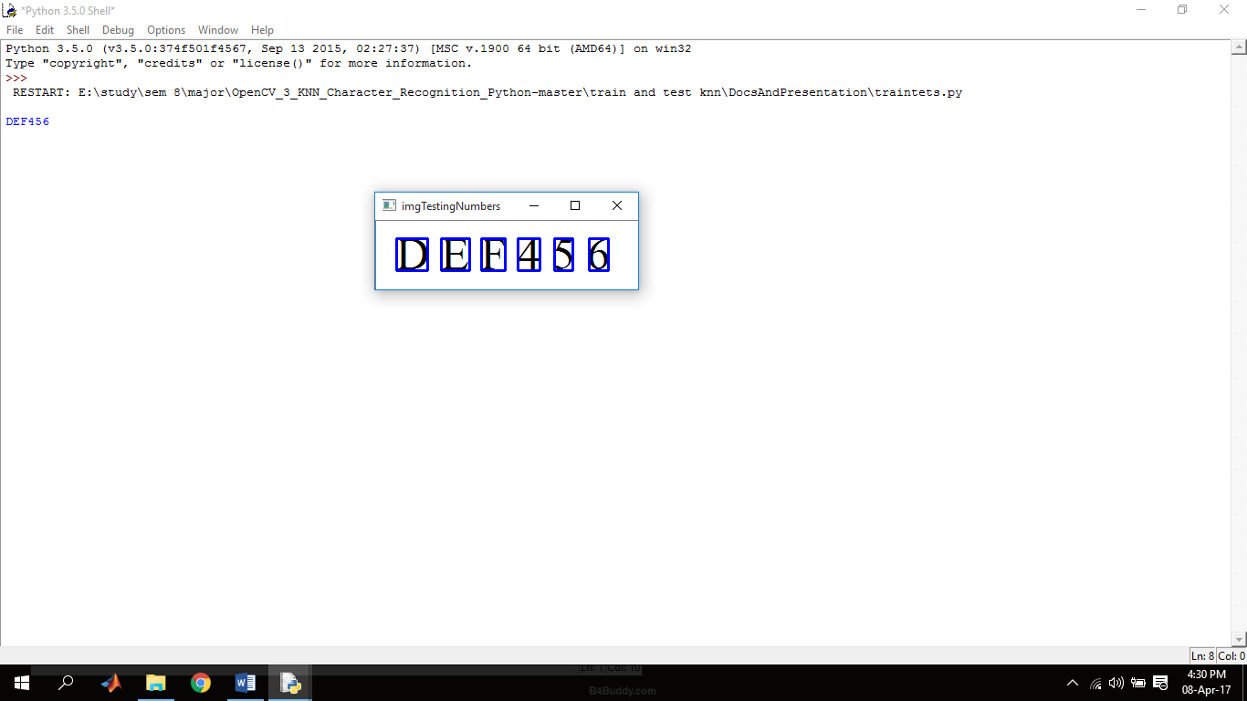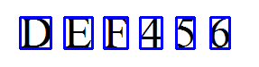

**Fig.12) shell output after training and testing**

**(33)**

**3.3) License plate Detection using K-NN**

1. **Original Image :**

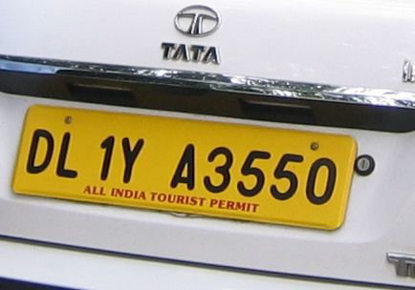

Fig.13) Original Image

1. 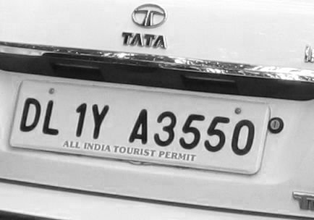Grayscale image :

Fig.14) Grayscale image

1. Threshold of the image:

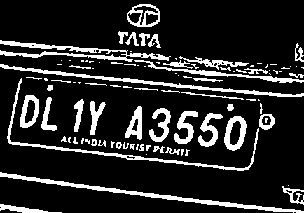

Fig 15) Threshold of the image

(34)

1. Drawing Contours :

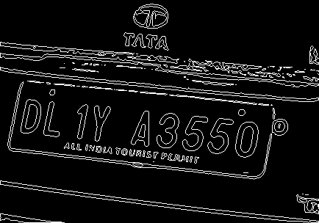

Fig. 16) image Contour (draw)

1. Smoothening of image (removing noise):

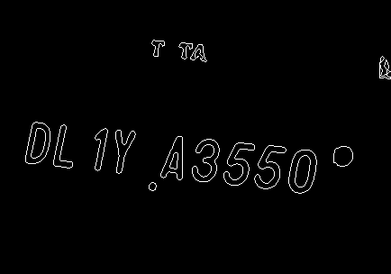

Fig. 17) Noise Removal using canny edge

1. Matching characters:

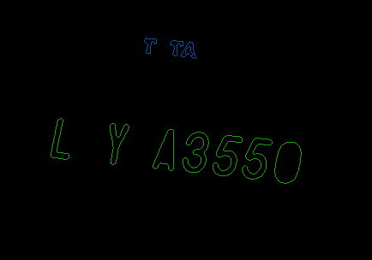

Fig. 18) Matching characters out of all possible strings

(35)

1. Drawing contours over the possible plates

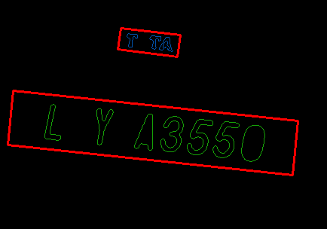

Fig.19) Possible Plates using the string length

1. Extracting the plates:

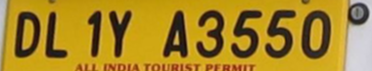

Fig.20a) 1st plate Fig.20b) 2nd plate

Discarding the previous one and using the later based on the length of string

1. 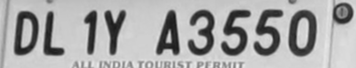Converting the image into grayscale:

Fig.21) Grayscale image of the extracted plate

10.) Threshold of the grayscale plate:

Fig.22) threshold of the grayscale image

(36)

11.) Smoothening (noise reduction) and resizing of the plate image:



Fig.23) Blurring and resizing of the image

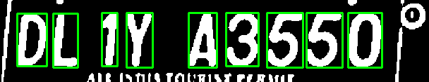12.) Segmentation:

Fig. 24) Segmented output

13.) Output:

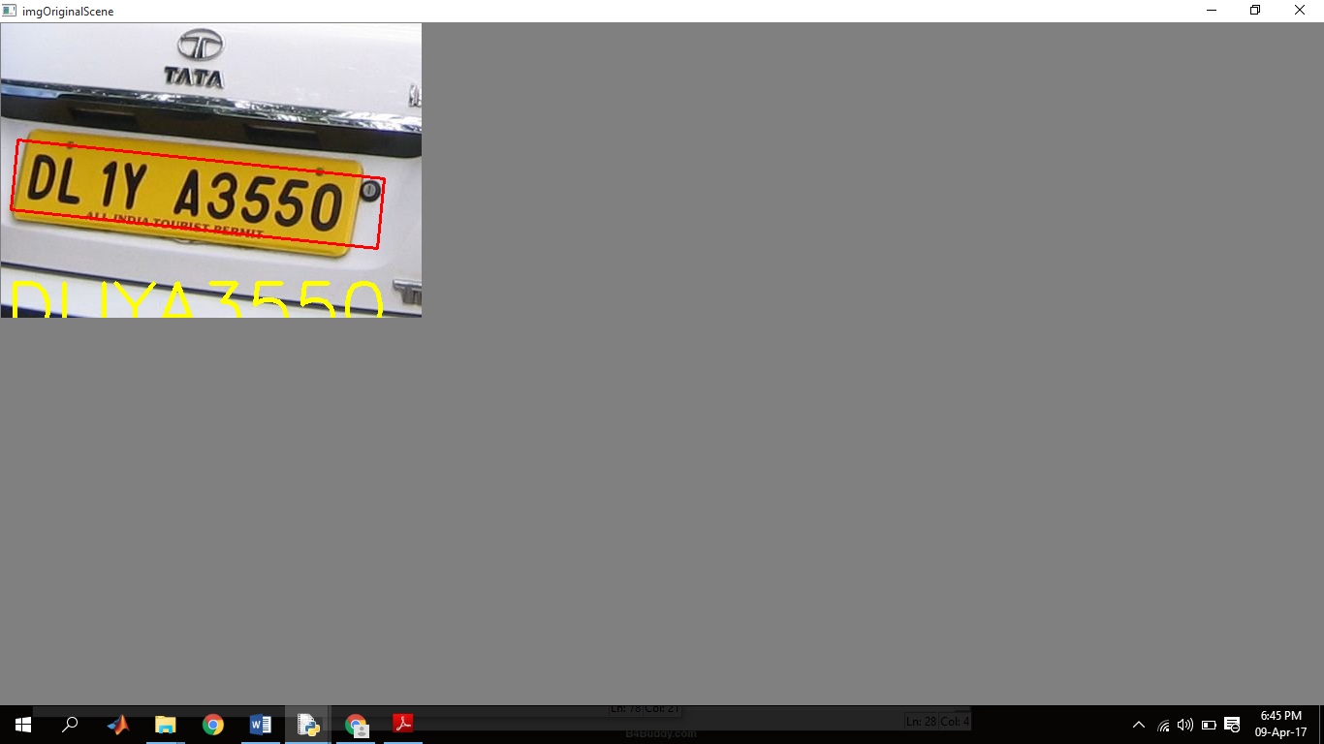

Fig. 25) Output on the original image:

(37)

14.) Shell Output :

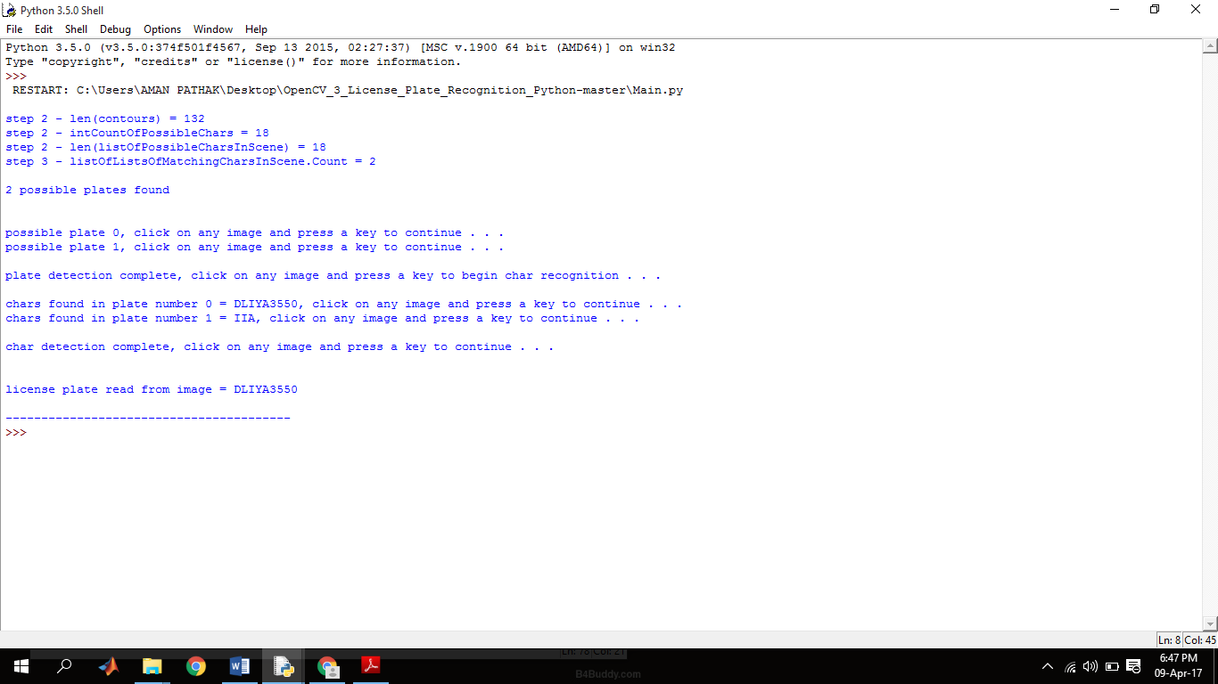

Fig. 26) Output on the python Shell

(38)

**Chapter -4**

**Result and discussion**

**Results:**

**Images produced after the python code was run on Raspberry pi with a static image.**

Original Image





Segmented Output

(39)

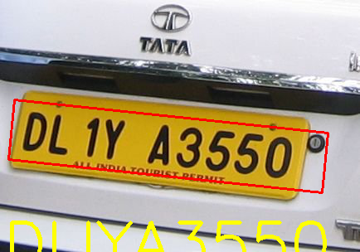

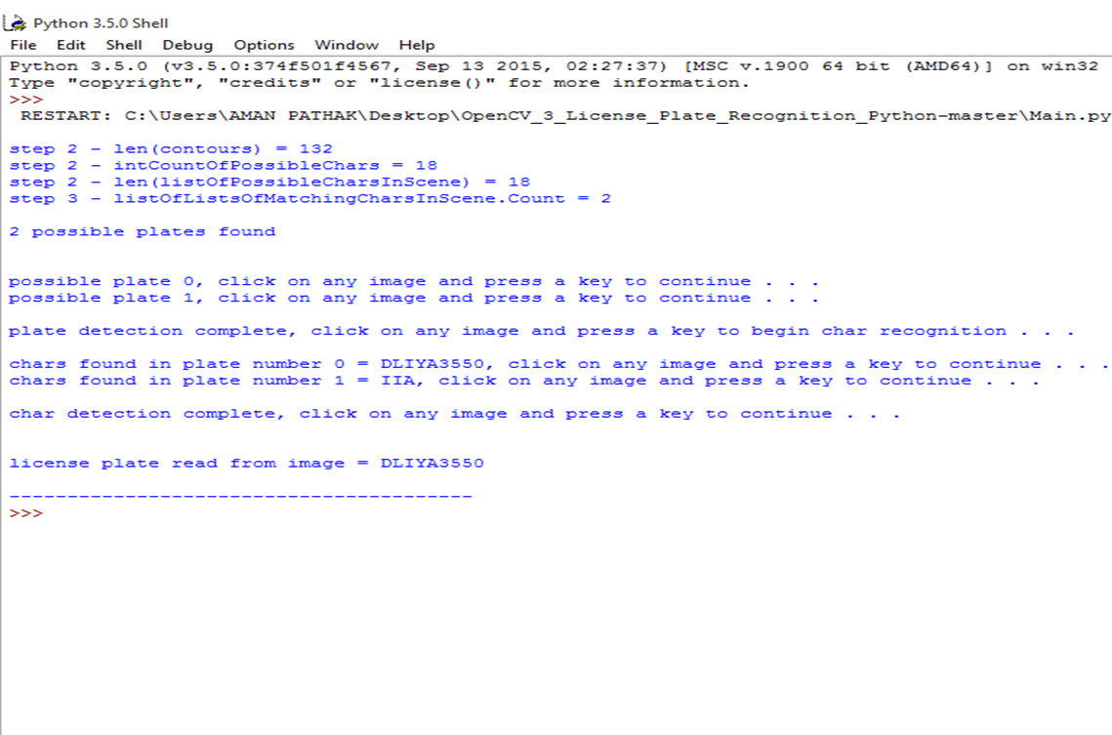 Output on the original image

Fig. (27) Python shell output

(40)

The Results obtained are as follows:

1. For the localization of license plate

Fig.28) Chart to show the efficiency of localization of license plate

* **Accuracy: System gave a total of 91.3% accuracy. Which is pretty good.**

(41)

1. For the segmentation

* Many Characters were confusing the system like in case of “4” it was showing alphabet k, “C” was treated as 0 “6” as 8, alphabet “R” as P, “3” as 8 and in this particular “1” was treated as I by the system.

1. Performance analysis of the image.

Fig.(29) Performance analysis

(42)

**Discussion:**

4.2) Why OpenCV was used?

Answer: We preferred OpenCV over MATLAB due to following reasons:

* Resource used by the software: MATLAB comparatively uses more memory than OpenCV.
* Portability: OpenCV can be used on any device that can run C, whereas this is not the case for the MATLAB.
* Speed : MATLAB is built on JAVA and JAVA is built upon C, So when running a MATLAB code this will take a lot of time to interpret the code, first converting it to java then executing it, whereas OpenCV is a in C/C++ so, it will be faster than the MATLAB
* Cost: MATLAB requires a license, whereas OpenCV is free.

4.3) Why python?

* Ease of use.
* Hardware like raspberry pi can be programmed easily for the processing work using python language.
* Python can be used for machine learning application, Easy to use and has already built modules for the machine learning applications.
* Require less memory.
* Open source

(43)

**Chapter -5**

**Conclusion**

**Conclusion:**

Proposed framework works productively even with a wide variety in lightning condition and different sorts of number plates. It can be a superior contrasting option to the current RFID or manual frameworks in India.

Well there are a few requirements on this framework like the

• Font on the number plate,

• cleanliness of the number plate

• Quality of picture caught

• Skew in the picture

These can be additionally enhanced by utilizing neural systems or by improving the

K-NN calculation facilitate by getting an ever increasing number of information and enhancing the exactness of the framework.

• For the character division, we watched that if there is not a reasonable limit between the characters then the division can't be completed effectively.

Additionally utilization of different textual styles require neural systems to recognize them, however that requires a great deal of information.

(44)

**Chapter -6**

**References**

.

[1]ALPR System , Pratiksha Jain, Neha Chopra, Vaishali Gupta (GGSIPU New Delhi, India**)**

[2] Edge detection tutorial: http:// [www.pages.derexel.edu/~weg22/edge.html](http://www.pages.derexel.edu/~weg22/edge.html)

[3] SVM Based LPR System by Kumar Parasuraman and Subin P.S, *Member IEEE* .

[4] Bonding box (contours) :OpenCV-python-tutroals.readthedocs.io

[5] Chen-Chung Liu, Zhi-Chun Luo(2010): An Extraction Algorithm of Vehicle License Plate Numbers Using Pixel Value Projection and License Plate Calibration, International Symposium on Computer, Communication, Control and Automation

[6] <https://www.youtube.com/watch?v=6j-Wy9j0TCs> : OpenALPR

[7]A byte of Python by Swaroop C H and OpenCV-Python Tutorials Documentation by Alexander Mordvintsev & Abid K

[8] K.M Sajjad , “ANPR Using Python and Open CV” Dept Of CSE, M.E.S College of Engineering Kuttipuram, kerala.2008-06-21

[9] Vehicle Classification And License Plate Recognition by Amlan Kar ,nishant Rai ,Department of CSE, IIT Kanpur.

[10] Openalpr: License plate recognition. <https://github.com/openalpr/openalpr>.

[11]Choudhury A Rahman, Wael Badawy, and Ahmad Radmanesh. A real time vehicle license plate recognition system (IEEE, 2003).

[12] Peter M. Roth, Martin K¨ostinger, Paul Wohlhart, and Horst Bischof, Josef A. Birchbauer (2010):7th IEEE International Conference on Advanced Video and Signal Based Surveillance

(45)